**IN CLASS # 4**

1. Consider a single crystal of some hypothetical metal that has the FCC crystal structure and is oriented such that a tensile stress is applied along a [02] direction. If slip occurs on a (111) plane and in a a [01] direction, compute the stress at which the crystal yields if its critical resolved shear stress is 3.42 MPa.

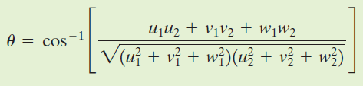 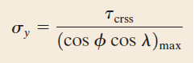

1. The lower yield point for an iron that has an average grain diameter of 5 × 10-2 mm is   
   135 MPa. At a grain diameter of 8 × 10-3 mm, the yield point increases to 260 MPa. At what grain diameter will the lower yield point be 205 MPa?

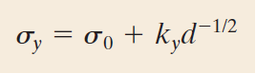

**IN CLASS # 4**

1. Consider a single crystal of some hypothetical metal that has the FCC crystal structure and is oriented such that a tensile stress is applied along a [02] direction. If slip occurs on a (111) plane and in a a [01] direction, compute the stress at which the crystal yields if its critical resolved shear stress is 3.42 MPa.

 

1. The lower yield point for an iron that has an average grain diameter of 5 × 10-2 mm is   
   135 MPa. At a grain diameter of 8 × 10-3 mm, the yield point increases to 260 MPa. At what grain diameter will the lower yield point be 205 MPa?

